# Student Analysis

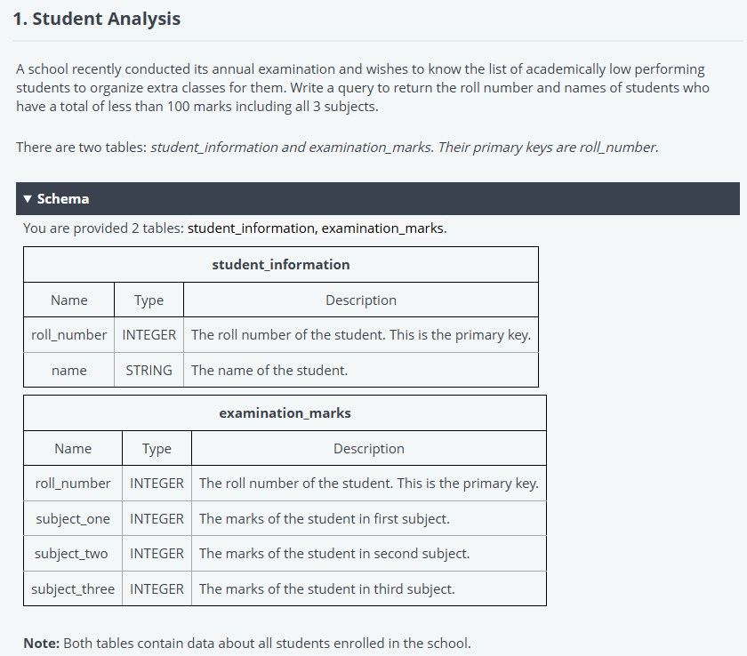

SELECT a.roll_number,a.name

FROM student_information a

INNER JOIN examination_marks b

ON a.roll_number = b.roll_number

GROUP BY b.roll_number

HAVING SUM(b.subject_one + b.subject_two + b.subject_three) < 100;

# Profitable Stocks

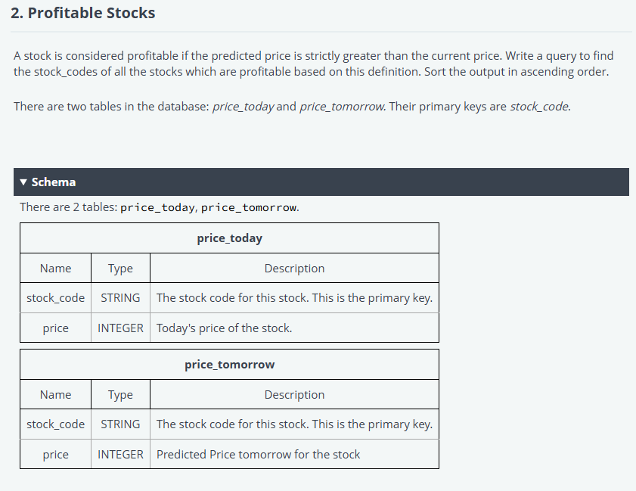

SELECT a.stock_code

FROM price_today a

INNER JOIN price_tomorrow b

ON a.stock_code = b.stock_code

WHERE b.price>a.price

ORDER BY stock_code asc;

# Country Codes

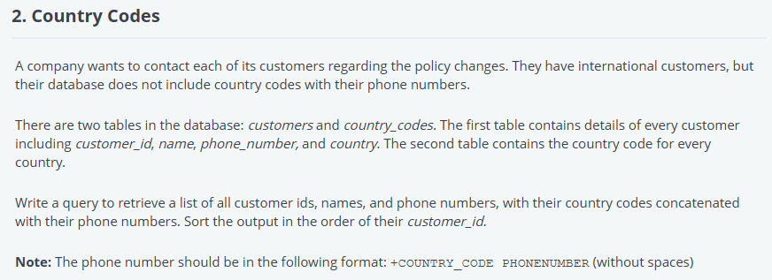

/*

Enter your query below.

Please append a semicolon ";" at the end of the query

*/

SELECT a.customer_id,a.name,concat("+",b.country_code,a.phone_number)

FROM customers as a

LEFT join country_codes as b

ON a.country=b.country

ORDER BY a.customer_id;